VIERNE Spleens et détresses, op. 38. Piano Quintet,op. 42 • Muza Rubackyte (pn); Anaïk Morel (mez); Terpsycordes Qrt • BRILLIANT 95367 (66:56)

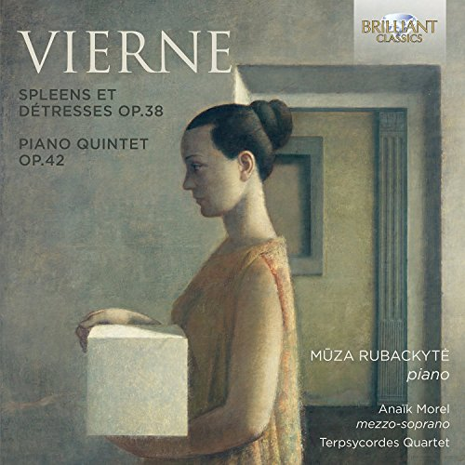
Louis Vierne: Spleens et Détresses, Op.38 & Piano Quintet, Op.42
Audio CD
Brilliant Classics
For those dining at a typical Brazilian churrascaria, each diner is given a card/coin that has a green side and a red side. This is true not only of the U.S.-based churrascarias but also those in the mother country where I’ve spent numerous occasions enjoying their food. When you turn the card to display “green” the roaming gauchos know to stop at your table to offer you their sumptuous meat selection. As long as your card stays “green” they will continue to ply you with their wares. Turn it over the “red” and they stop visiting you. This is what came to mind while listening to this CD of two works of Louis Verne. Each work comprises half the playing time, and there is one half that I would label “green” all day long while the other would be a full-stop “red.”
Starting with the “green” side, we have the piano quintet—a full-fledged near-masterpiece of a composition written in 1917 after receiving news that his 17-year-old son had been killed in action in the war. The work is full of passionate grief, sorrowful longing, and bitter melancholy. It is in many ways the equal of the Franck Quintet in musical substance and, perhaps, even surpasses it in excellence. Written in the chromatic style typical of the late-Romantic French composers, Vierne launches the first movement in C Minor, where two main themes are developed. The second movement continues the somber mood and it is not until the third and final movement that an agitated mode breaks out with pounding keys and vehement strings. This vigorous music collapses into an eerie stillness, where the first movement’s passionate theme reappears, only to be exploded with a fiery coda. Yes, this music is “green” all the time for me—it is excellent through and through. The Terpsycordes Quartet, anchored at the piano by Muza Rubackyte, perform the daylights out of it, giving full sway to the emotional content in a satisfying and dynamic performance.
I am familiar with just one other performance of the Piano Quintet, and that is by Le Groupe de Chambre de Montreal on a Musica Viva CD from 1995. This Canadian ensemble couples the quintet with the Vierne Cello Sonata, a much more apt coupling. In the quintet, the Canadians cut about 3 minutes off of this work by shaving time in all three movements. I think their performance is quite fine, but I like Muza Rubackyte and team even more for their more emotional performance. I don’t know the recordings of the quintet on Hyperion, Tympani, Gramola, MDG, or Atma, so there are plenty to choose from. What I can say with assurance is that this present release is excellent in every way and it does Vierne and his powerful piano quintet proud.
Now to the “red” side—that would be the remaining half of this release, comprised of the song cycle Spleens et détresses based on poems by Paul Verlaine. I don’t mean to suggest that the performance by mezzo-soprano Anaïk Morel and pianist Rubackyte is in any way deficient because it is not—it seems like a fine performance. But the music itself is simply not very attractive to me. I am not a “song cycle” kind of guy, so this music doesn’t fall gently on my ears and it was a struggle for me to give it even two listens. Perhaps another Fanfare reviewer more sympathetic to this genre will give a listen and report. As for me, I have no plans to play it again.
So that is the tale of “green” and “red” on this disc of Vierne chamber music. The Piano Quintet is a wonderful work, very well performed and recorded and well worth your attention. I only wish they’d chosen to drop the song cycle in favor of other instrumental chamber music by this composer. Mark Novak

